 [Translated from German to English - www.onlinedoctranslator.com](https://www.onlinedoctranslator.com/en/?utm_source=onlinedoctranslator&utm_medium=docx&utm_campaign=attribution)

**Christian'**

*WHOEINIIMMWMEMMEINIW*

**Technical Institute for Education and Training**

**mMS training concept**

**Mechatronics/Automation Technology**

**Technical documentation**

**Functional module**

**Pneumatic press**

**Order No. 64399 1st Edition 02/04**

0 by Dr,-Ing_ Paul Christiani GmbH & Co. KG

© by Dr.-Ing. Paul Christiani GmbH & Co. KG **3**

|  |  |  |
| --- | --- | --- |
| Pneumatic press | | Technical documentation |
| **Table of contents 'I mechanics** | |  |
| 1.1 | Functional description | 5 |
| 1.2 | Overall drawing | 7 |
| 1.3 | Complete parts list | 11 |
| **2** | **E-pneumatics** |  |
| 2.1 | Pneumatic plan | 17 |
| **3** | **Electrics** |  |
| 3.1 | Circuit diagram / terminal plan | 19 |
| **4** | **PLC program** |  |
| 4.1 | Program description | 29 |
| 4.2 | Technology scheme | 31 |
| 4.3 | Function plan | 33 |
| 4.4 | Program steps | 37 |
| **5** | **Commissioning instructions** | 43 |

**1 Mechanics**

Pneumatic press Technical documentation

0 by Dr.-Ing. Paul Christian' GmbH & Co. KG 5

**1.1 Functional description**

In the pneumatic press, workpieces can be processed with a force of approx. 220 N (at 4 bar).

After inserting the workpieces, the workpiece holder transports the parts to be machined into the press chamber. The safety­tar and the press cylinder begins to extend. After processing,the protective gates and the workpieces are removed from the work area­pushed and are ready for further transport.

The safety door ensures that the press has a completely enclosed working area during the pressing process, and the Plexiglas safety walls allow­However, monitoring the pressing process is necessary. To further increase safety, two-hand operation is used for manual operation.

The functional assembly is mounted on 2 profile plates and can be installed together with other assemblies on an aluminum grooved plate.

Two 8-bit transfer connectors are available as transfer modules for connection to six digital PLC inputs and eight digital PLC outputs.

The supply voltage of the functional module is 24 VDC and is provided via the 10-pin connecting cable.

The air supply is via 4 mm air connection, the operating pressure is4 bar.

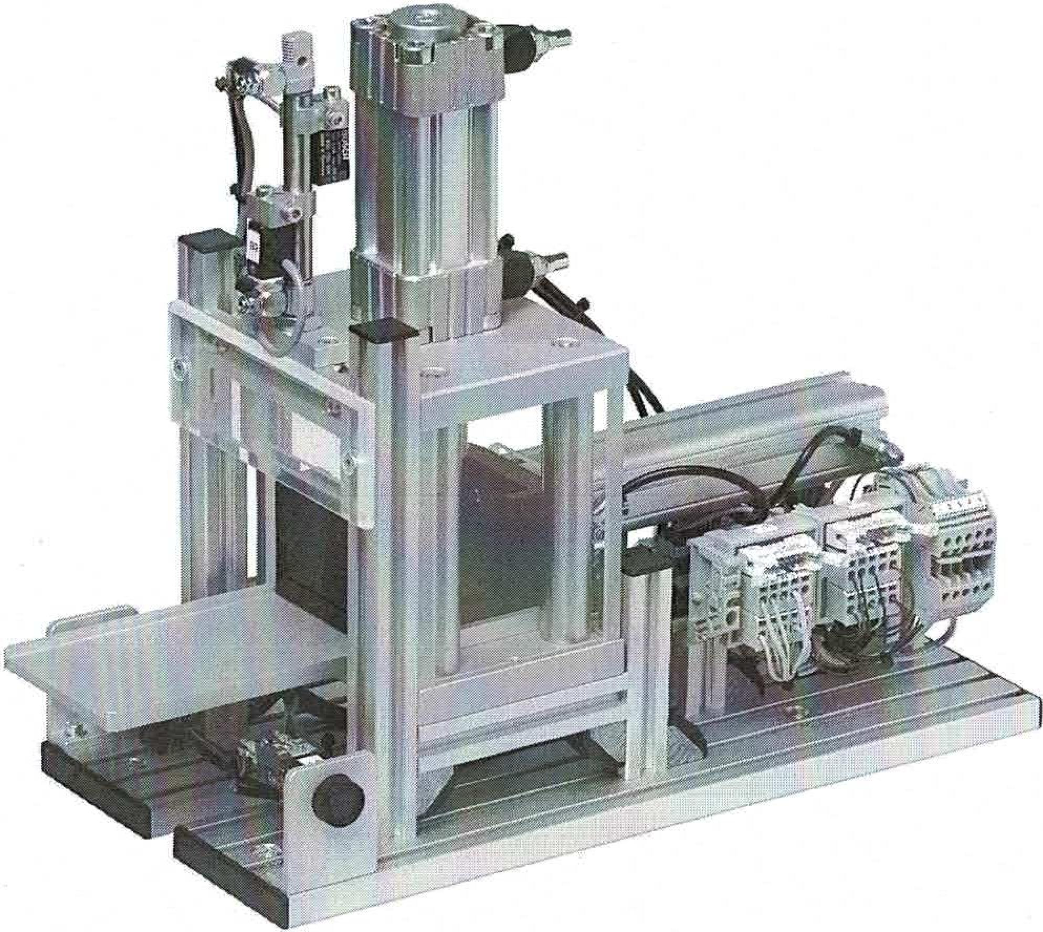

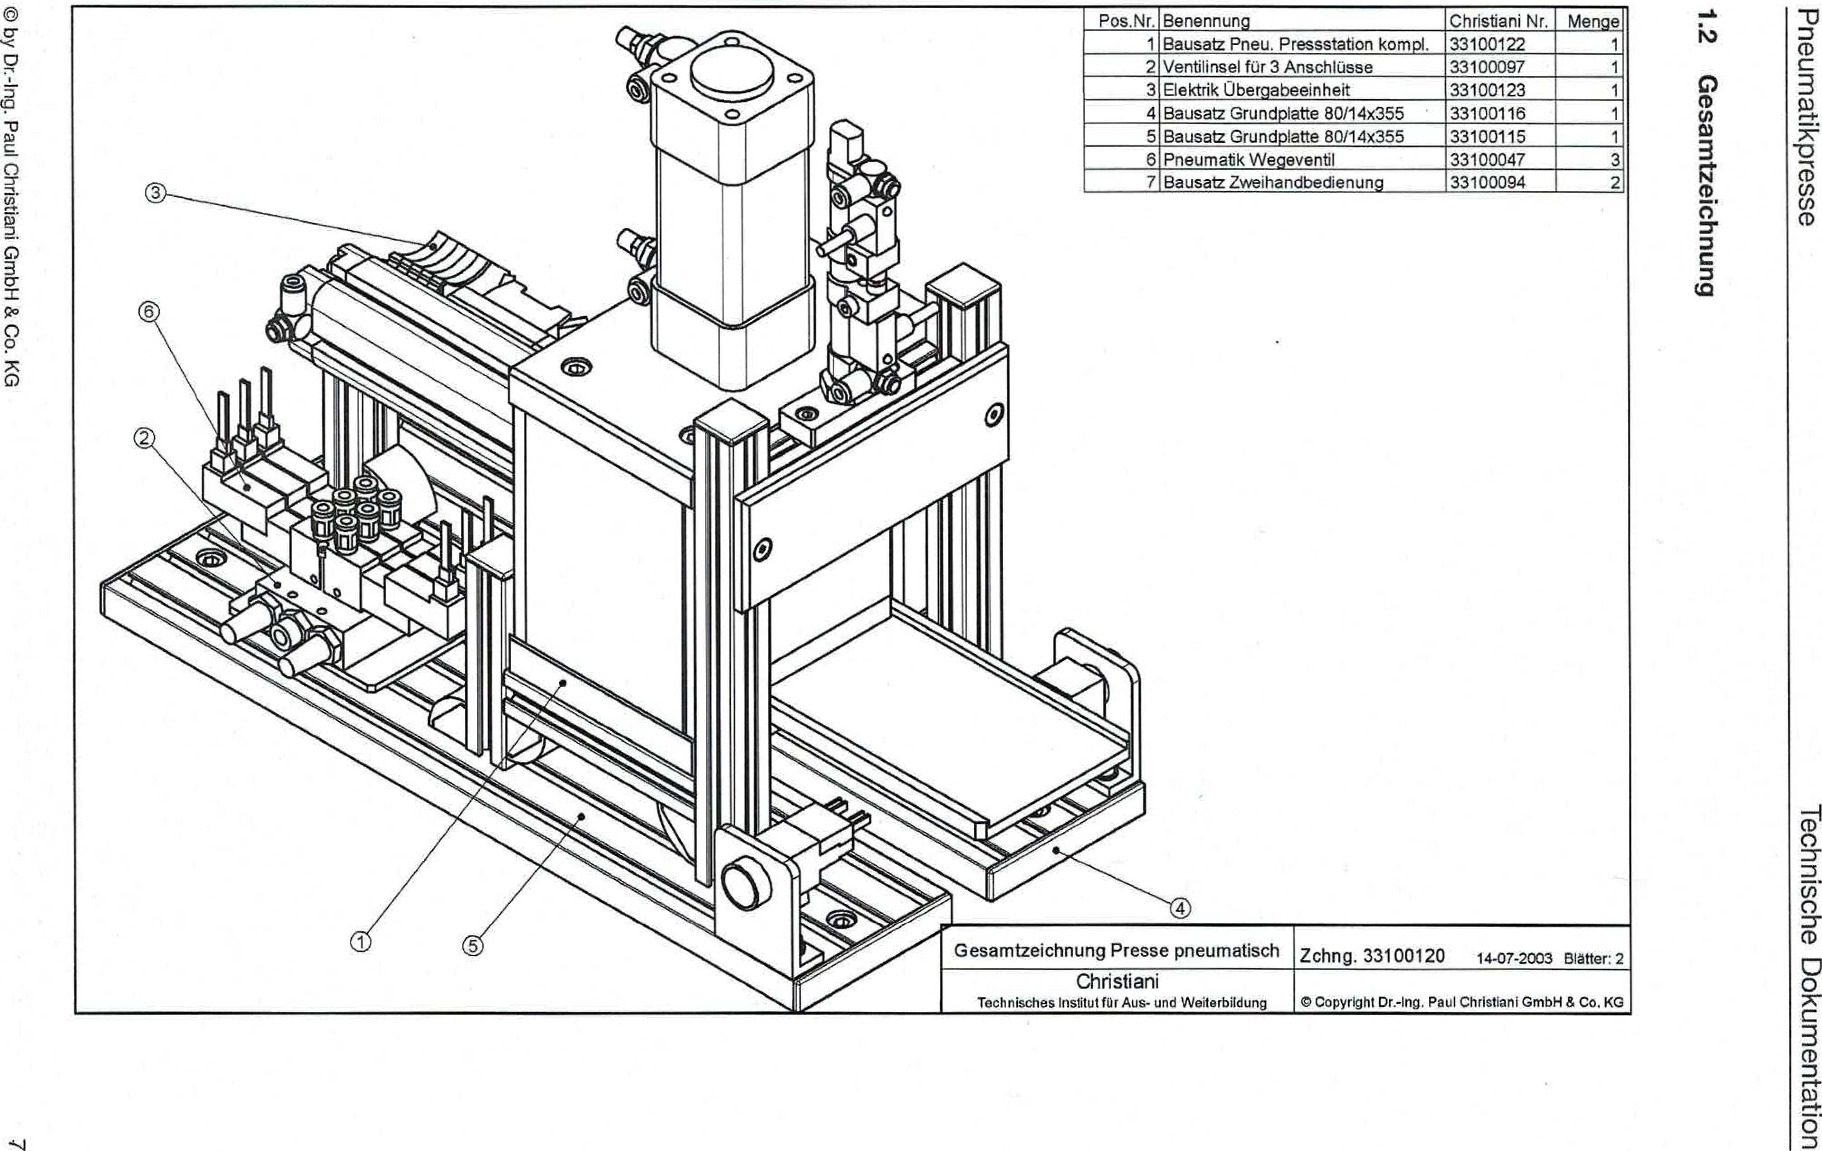

C) by Dr-Ing. Paul Christiani GmbH & Co. KG

**6unuippziwesao**

essaithipewnaud

uo!leluawmioa agaspLioai

|  |  |  |  |
| --- | --- | --- | --- |
| **Item No.** | **designation** | **Christiani No.** | **Crowd** |
| **1** | **Complete tire press station kit.** | **33100122** | **1** |
| **2** | **Valve island for 3 connections** | **33100097** | **1** |
| **3** | **Electrical transfer unit** | **33100123** | **1** |
| **4** | **Base plate kit 80/14x355** | **33100116** | **1** |
| **5** | **Base plate kit 80/14x355** | **33100115** | **1** |
| **6** | **Pneumatic valve** | **33100047** | **3** |
| **7** | **Two-hand operation kit** | **33100094** |  |

General drawing of pneumatic press

Christiani

Technical Instruction for Training and Education

Drawing 331 00120 14-07-2003 Adder: 2

0 Copyright Dr.-Ing. Paul Christiani GmbH & Co. KG

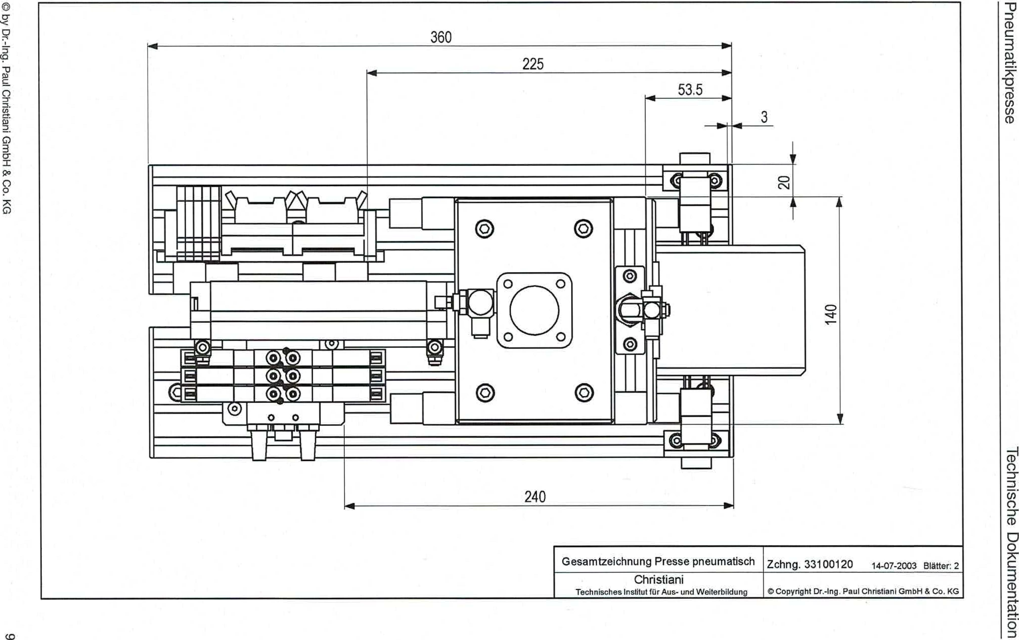

0 by Dr-Ing. Paul Christiani GmbH & Co. KG

CO

assalthiRewneud

uoquluownwo agosploal

14-07-2003 Blatter: 2

General drawing of pneumatic press drawing 33100120

360

225

53.5

3

Christiani

Technical Institute tar Training and Further Education © Copyright Dr.-Ing. Paul Chnstiani GmbH & Co. KG

•

tir

L__I

240

**1.3 Total item list**

Pneumatic press Technical documentation

0 by Dr.-Ing. Paul Christiani GrnbH & Co. KG

11

|  |  |  |  |
| --- | --- | --- | --- |
| **Item No.** | **Number** | **component** | **Drawing no.** |
| **01.00 Complete tire press station kit (Z33100120)** | | | |
| 01.01 | 1 | Complete tire pressing station kit | 33100122 |
| 01.02 | 1 | Valve island Mr 3 connections | 33100097 |
| 01.03 | 1 | Electrical transfer unit | 33100123 |
| 01.04 | 1 | Base plate kit 80/14x355 | 33100116 |
| 01.05 | 1 | Base plate kit 80/14x355 | 22100115 |
| 01.06 | 3 | Pneumatic directional valve | 33100047 |
| 01.07 | 2 | Two-hand operation kit | 33100094 |
| **02.00 Complete tire pressing station kit (Z33100122)** | | | |
| 02.01 | 1 | Press station assembly kit 1 | 33100099 |
| 02.02 | 1 | Press station assembly kit 2 | 33100090 |
| 02.03 | 1 | Slider kit | 33100084 |
| 02.04 | 2 | Press station assembly kit 3 | 33100095 |
| **03.00 Pneumatic Pressing Station Assembly Kit 1 (Z33100099)** | | | |
| 03.01 | 2 | Al-Profit 20x20x98 (34053286) | 36100142 |
| 03.02 | 1 | Base plate 98/15x138 | 36100113 |
| 03.03 | 2 | Cylinder head screw ISO 4762-M4x25-8.8 | 35100050 |
| 03.04 | 4 | Saute 20x105 | 36100137 |
| 03.05 | 8 | Cylinder head screw ISO 4762-M6x20-8.8 | 35100049 |
| 03.06 | 1 | Cover 98/15x138 Pneu. | 36100144 |
| 03.07 | 1 | Cylinder 08 22 350 600 D=32 Stroke=25 | 34053273 |
| 03.08 | 1 | Stamp D= 30**H=**22 | 36100145 |
| 03.09 | 1 | Hexagon nut M14x1.5 | 35100052 |
| 03.10 | 2 | Throttle check valve G118 | 34053091 |
| 03.11 | 1 | Leadership | 36100119 |

Technical documentation Pneumatic press

12 © by Dr.-Ing. Paul Christiani GmbH & Co. KG

|  |  |  |  |
| --- | --- | --- | --- |
| 03.12 | 1 | Holder for cylinder | 36100127 |
| 03.13 | 1 | Cylinder D= 20 Stroke= 120 | 34053329 |
| 03.14 | 6 | Countersunk screw ISO 10 642 - M5x16-8.8 | 35100071 |
| 03.15 | 2 | Plexiglass cladding | 36100128 |
| 03.16 | 1 | Plexiglass back wall | 36100129 |
| 03.17 | 1 | Front wall plexiglass | 36100130 |
| 03.18 | 4 | Angle 20x20 NU6 | 34053003 |
| 03.19 | 4 | Angle cover cap 20x20 | 34053004 |
| 03.20 | 8 | Cylinder head screw ISO 4762-M4x8-8.8 | 35100000 |
| 03.21 | 4 | T-slot nut M4 NU6 | 34053319 |
| 03.22 | 4 | Hammer nut M4 NU6 | 34053006 |
| 03.23 | 2 | Cylinder head screw ISO 4762-M6x16-8.8 | 35100005 |
| 03.24 | 2 | Throttle check valve M5 exhaust air throttled. | 34053060 |
| 03.25 | 2 | cylinder switch | 34053094 |
| 03.26 | 4 | Cylinder head screw ISO 4762-M6x25-8.8 | 35100054 |
| **04.00 Press station assembly kit 2 (Z33100090)** | | | |
| 04.01 | 2 | Al profile 20x20x204 (34053286) | 34053286 0204  _ |
| 04.02 | 1 | Al profile 20x20x100 (34053286) | 36100131 |
| 04.03 | 2 | Internal angle NU6 with 2 threaded rods M4 | 34053310 |
| 04.04 | 1 | TOr Plexiglas | 36100138 |
| 04.05 | 2 | Clamp holder for cylinder switch d=10 | 34053058 |
| 04.06 | 2 _ . | Cylinder switch for cylinder d=10 | 34053059 |
| 04.07 | 2 | Throttle check valve M5 exhaust air throttled. | 34053060 |
| 04.08 | 2 | Cover cap 20x20 black | 34053030 |
| 04.09 | 1 | Plate 18/8x54 | 36100140 |
| 04.10 | 6 | Hammer nut M4 NU6 | 34053006 |
| 04.11 | 6 | Cylinder head screw ISO 4762 - M4x8 - 8.8 | 3510000 |
| 04.12 | 1 | Plexiglass cladding | 36100132 |
| 04.13 | 2 | Countersunk screw ISO 10 642 - M5x16-8.8 | 35100030 |

Pneumatic press Technical documentation

by Dr.-Ing. Paul Christiani GmbH & Co. KG

13

|  |  |  |  |
| --- | --- | --- | --- |
| 04.14 | 1 | Pneumatic round cylinder D= 10 stroke= 40 | 34053175 |
| 04.15 | 2 | Angle cover cap 20x20 | 34053004 |
| 04.16 | 2 | Angle 20x20 NU6 | 34053003 |
| 04.17 | 2 | T-slot nut M4 NU5 steel | 34053297 |
| 04.18 | 2 | Cylinder head screw ISO 4762-M4x20-8.8 | 35100039 |
| 05.00 Slider kit (Z33100084) | | | |
| 05.01 | 1 | Slider lower part | 36100118 |
| 05.02 | 1 | Slider upper part | 36100117 |
| 05.03 | 1 | Slider upper part | 36100126 |
| 05.04 | 4 | Cylinder head screw ISO 4762 - M6x16 - 8.8 | 35100005 |
| 05.05 | 2 | Cylinder head screw ISO 4762 - M4x16 - 8.8 | 35100001 |
| 06.00 Press station assembly kit 3 (Z33100095) | | | |
| 06.01 | 1 | Al profile 20x20x85 | 34053286_0085 |
| 06.02 | 1 | Cover cap 20x20 | 34053030 |
| 06.03 | 1 | Angle 20x20 NU6 | 34053003 |
| 06.04 | 2 | Cylinder head screw ISO 4762 - M4x8 - 8.8 | 35100000 |
| 06.05 | 1 | T-slot nut M4 NU5 steel | 34053297 |
| 06.06 | 1 | Angle cover cap 20x20 | 34053004 |
| 06.07 | 1 | Hammer nut M4 NU6 | 34053006 |
| 07.00 Valve island for 3 connections (Z33100097) | | | |
| 07.01 | 1 | Connection point 3x | 36053061 |
| 07.02 | 2 | Silencer G1/8" | 34053062 |
| 07.03 | 3 | Locking screw G1/8" | 34053063 |
| 07.04 | 1 | Hose connection D= 4mm G1/8" | 34053318 |
| 07.05 | 1 | Base plate for valve island | 36100143 |
| 07.06 | 6 | Countersunk screw ISO 10 642 - M4x8 - 8.8 | 35100031 |
| 07.07 | 2 | T-slot nut M4 NU5 steel | 34053297 |
| 07.08 | 2 | Plastic hose 4mm-1 m | 34060502_1000 |

Technical documentation Pneumatic press

14

**© by Dr.-Ing. Paul Christiani GmbH & Co. KG**

|  |  |  |  |
| --- | --- | --- | --- |
| **08.00 Electrical transfer unit (Z33100123)** | | | |
| 08.01 | 1 | DIN rail TS35 L=140 | 34053325_0140 |
| 08.02 | 2 | Cylinder head screw ISO 4762-M4x6 - 8.8 | 35100018 |
| 08.03 | 2 | Washer DIN 125 - A 4.3 - 140HV-A2 | 35100004 |
| 08.04 | 4 | Hammer nut M4 NU6 | 34053006 |
| 08.05 | 2 | Input and output module | 34053290 |
| 08.06 | 2 | End angle | 34060000 |
| 08.07 | 5 | Terminal block WDU 2.5 | 34060475 |
| 08.08 | 1 | End separation plate WAP 2.5 | 34060806 |
| 08.09 | 1 | Cross connector WDU 2-pin | 34060885 |
| 08.10 | 1 | Cross connector WDU 3-pin | 34060887 |
| 08.11 | 2 | AL profile 20x20x70 | 34053286_0070 |
| 08.12 | 2 | Cover cap 20x20 | 34053030 |
| 08.13 | 2 | Angle 20x20 NU6 | 34053003 |
| 08.14 | 4 | Cylinder head screw ISO 47962 - M4x8 - 8.8 | 35100000 |
| 08.15 | 2 | Angle cover cap 20x20 | 34053004 |
| 08.16 | 2 | T-slot nut M4 NU5 steel | 34053297 |
| 08.17 | 1 | Wiring kit | 34053388 |
| **09.00 Base plate kit 80/14x355 (Z33100116)** | | | |
| 09.01 | 1 | Grooved plate 80/14x355 (34053295) | 36100173 |
| 09.02 | 2 | Cover cap 80x14 black | 34053296 |
| 09.03 | 2 | Hammer nut M6 NU8 | 34053028 |
| 09.04 | 2 | Cylinder head screw DIN 7984 - M6x16 - 8.8 | 35100028 |
| **10.00 Base plate kit 80/14x355 (Z33100115)** | | | |
| 10.01. | 1 | Grooved plate 80/14x355 (34053295) | 36100172 |
| 10.02. | 2 | Cover cap 80x14 black | 34053296 |
| 10.03. | 2 | Hammer nut M6 NU8 | 34053028 |
| 10.04. | 2 | Cylinder head screw DIN 7984 - M6x16 - 8.8 | 35100028 |

Pneumatic press Technical documentation

© by Dr-Ing. Paul Christiani GmbH & Co. KG

15

|  |  |  |  |
| --- | --- | --- | --- |
| 11.00 pneumatic directional control valve (3x) (Z33100047) | | | |
| 11.01 | 1 | 5/2-way valve 2x24 V DC connection M5 | 34053064 |
| 11.02 | 2 | Device connector for directional control valve with cable | 34053065 |
| 11.03 | 2 | Hose connection 4mm M5 | 34053089 |
| 12.00 Two-hand operation kit (Z33100094) | | | |
| 12.01 | 2 | Bracket | 36100139 |
| 12.02 | 4 | T-slot nut M4 NU5 steel | 34053297 |
| 12.03 | 4 | Cylinder head screw ISO 4762 - M4x8 - 8.8 | 35100000 |
| 12.04 | 2 | Illuminated push button switch blue 16mm | 34053015 |
| 12.05 | 4 | Disc DIN 125-A4.3- 140HV-A2 | 35100004 |
| 12.06 | 1 | Cable lugs 2.8 mm — 20 pcs. | 34053414 |

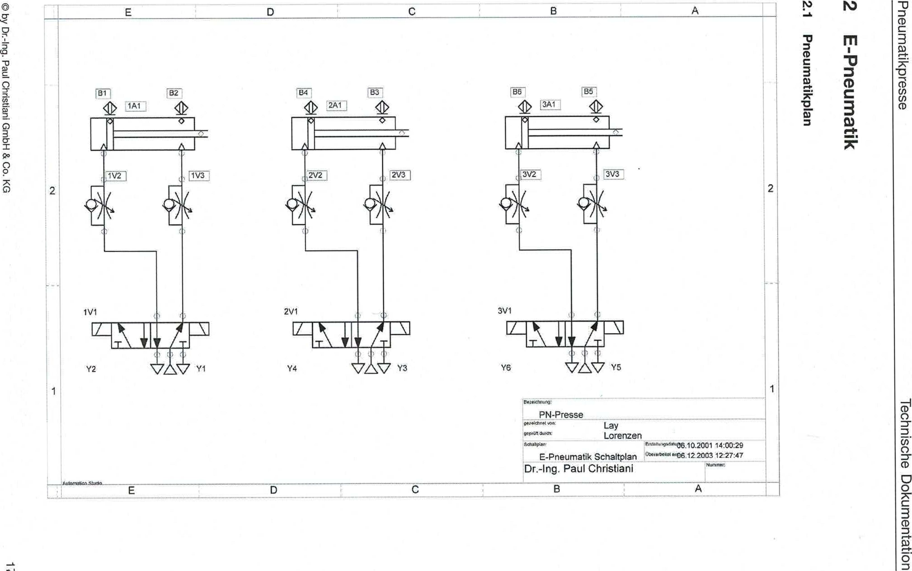

A t12,

B

C

E D

**ueichmetunaud**

assaAdvIewnaud

**Agewneud-3**

2

© by Dr.-Ing. Paul Christian' GmbH & Co. KG

not luawnwa aps!uqoal

**PT.**

T34

ri

1 Ai--I

**2A1**

186

DAL

2

Lay Lorenzen

**0"116.10.2001 14:00:29**

E-Pneurnatik circuit diagram.°°•"4*"006.12200,44..312:27:47

Dr.-Ing. Paul Christiani

**.!AUteM1014..SW10.**

A

etteethono:

PN Press

IgOreEctmekors.

Igepriil f,chal4.11

© by DrAng. Paul Christiani GmbH & Co. KG

CO

|  |  |
| --- | --- |
| **aueldueuuweiNmeldineiwcuis** | essaithisRnewneandd  **uopluawmpa agospial** |
|  |  |

|  |  |  |  |  |  |  |  |  |  |  |  |  |  |  |  |  |  |  |  |  |  |  |  |  |  |  |  |  |  |  |  |  |  |  |  |  |
| --- | --- | --- | --- | --- | --- | --- | --- | --- | --- | --- | --- | --- | --- | --- | --- | --- | --- | --- | --- | --- | --- | --- | --- | --- | --- | --- | --- | --- | --- | --- | --- | --- | --- | --- | --- | --- |
| 0 I 1 I 3 i J I ,.4 I 3 I 3 I / I 6 I d | | | | | | | | | | | | | | | | | | | | | | | | | | | | | | | | | | | | |
| -X001 2 o3 | | | | | | | | | | | | | | | | | | | | | | | | | | | | | | | | | | | | |
|  | |  | | | | | |  | | | | | | 04 | | | | 05 | | | | | |  | | | | _1.3_ _X1  -Slin51, | | | 2-1:.4.fX12 | | | | | |
|  | |  | | | | HN | | | | | | 00 | | | | RN | | RU | | | | ON | | RU | |
| -Bl | |  | | | |  | | |  | | |  | 7.--- | | | |  | | ••= | | | | ..sH5E. |
|  | | | | | BU | | | | | | OU | | | | BK | | | | | | t5.  BK | | | | 1.4 rX2  M | | | M | | | | |
| -X2 | L+ | | | L- 00.0 00.1 00.2 00. 3 | | | | | | | | | | | | | | | | | | | | | | | | | 0.4 | | | 0.5 40.5 40.7 | | |  | |
| ..SVii,  .,:v-2,41_.  .---  • | |  | |  | | | | | | | | | | | | | | | | | | | | | | | | | | | | | | | | |
| OLV.i.41-   * ,Vi2 9   Security door Security door Ejection river thrust button button reserve reserve  open below extended retracted right left | | | | | | | | | | | | | | | | | | | | | | | | | | | | | | | | | | | | |
| I | | | | | | | ''''' | | | | 18 '''''''"3 | **RIZE:=1- , - ,...,**.i.,4116,,  •  .......... | | | | | | | | | | PNEUMATIC PRESS | | | | | | | |  | | |  | * 111: | | |
| ,CP | | |
|  | | |  | | | | Ever b, | | | | 000 |
| VI.. 0 |  | | electric. 2 |
| CHRISTTANI GmbH & Co, KG | | | | | | | | | |
|  | | |  | |  | | Olaw. | | | | I., mov.2001 |
| 7et. |
| And.runa | | | Date | | Hama | | HaeA | | | |  | tirsor. lErs.f. | | | | | | | | | | C,* d. | | | | | | | |

essaithm.ewneud

uopluewmpa eijospipei

0 by Dr.-Ing. Paul Christian' GmbH & Co. KG

|  |  |  |  |  |  |  |  |  |  |  |  |  |  |  |  |  |  |  |  |  |  |  |  |  |  |  |  |  |  |
| --- | --- | --- | --- | --- | --- | --- | --- | --- | --- | --- | --- | --- | --- | --- | --- | --- | --- | --- | --- | --- | --- | --- | --- | --- | --- | --- | --- | --- | --- |
| la I 1 1 2 I 3 14 17 F , [ *2* 1 a 1 a | | | | | | | | | | | | | | | | | | | | | | | | | | | | | |
| .syn. s  .53-251♦  .--- | |  | | | | | | | | | | | | | | | | | | | | | | | | | | | |
| .53-251-  .SV/2.9 | |  | |  | | | | | | | | | | | | | | | | | | | | | | | | | |
| -XI | PL+0L- | | |  | | 00.0 | | | | | 00.1 | | 00.2 | | | 00.3 | | 00.4 | | | 00.5 | | 00.6 | | | 00.7 | |  | |
|  | | | | -Y1=- | | R1 r,  -Y2  R2 | | | | | R1 r,  1-t. -r3=-  R2 | | Rl"  t -rt4=-  R2 | | | R1,  ,t, -SH5®  R2 2. 6 | | X1  -SH60  X2 2, 7  ,.. | | | XI  -Y5=-  X2 | | R1 r,  t -Y6  R2 | | | Al v A2-A | | | |
|  | | |  | | | | |  | |  | | |  | |  | | | | |  | | |  | | |
| O " ∎ O , ∎ O , ∎  -X0 5 7 8 9  Security door Security door Ejection Rushub right left Rubber stamp Rubber stamp  open close extend retract reduce lift | | | | | | | | | | | | | | | | | | | | | | | | | |
|  | | | | |  | | | Date | LEL**50p.**2003 | **awartm.,,,,., ,4._.n., ,...,:,,,,** | | | | | PNEUMATIC TABLES PRESS | | | | |  | |  | | | -MIS | | | | |
| *FP | | | | |
|  | | |  | |  | | | Floarb | OHS |
| V1.0 | | |  | | | | 31. 3 |
| CHRISTIPNI GmbH & Co. KG | | | | |
|  | | |  | |  | | | Certified, , | 24. Hoy. 2003 |
| 7 Ill. |
| Anot.ung | | | t.  Date | | :S ame | | | standard |  | original lErs f, | | | | | Era. a, | | | | |

ID by Dr-Ing. Paul Christiani GmbH & Co. KG

Cu)IV

assaithipwnaud

uopluawnwa etios!upai

|  |  |  |  |  |  |  |  |  |  |  |  |  |  |  |  |  |  |  |  |  |  |  |  |  |  |  |  |  |
| --- | --- | --- | --- | --- | --- | --- | --- | --- | --- | --- | --- | --- | --- | --- | --- | --- | --- | --- | --- | --- | --- | --- | --- | --- | --- | --- | --- | --- |
| 0 1 1 I 2 1 3 1 1 1 5 I , 1 1 I d 1 9 | | | | | | | | | | | | | | | | | | | | | | | | | | | | |
| Klearning plan ESSK0990 07. i2. 21301 | | | | | | | | | | | | | | | | | | | | | | | | | | | | |
| Function text | | | | | |  |  |  |  | aweuracieN | Bar designation =MMS+PP—X0 | | | | | | | | | | atueutacieN |  |  | |  |  | Page/ path | |
|  |  |  |  | dA1 | Target name | | clrity7SUll | advice - advice | Bridges | Barley-  connection | | Target name | | unt43suu | dAl |  |  | |  |  |
|  | | | | | |  |  |  |  |  | -151 | | BN BN | 1  2 | i |  | | -X2-B2 | | BN |  |  |  | |  |  | /2.0 | |
| Security door below | | | | | |  |  |  |  | -63 | |  |  | |  |  | /2.3 | |
| Rushub retracted | | | | | |  |  |  |  | -SH6 | | 13 | 3 |  |  | | -B4 | | BN |  |  | |  |  | /2.5 | |
| Security door below | | | | | |  |  |  |  | -B3 | | BU | 4T |  |  | | -X2 | | L- |  |  | |  |  | /2.3 | |
| Russchub extended | | | | | |  |  |  |  | -84 | |  | 5 |  |  | |  | |  |  |  | |  |  | /2.4 | |
|  | | | | | |  |  |  |  |  | -Y1 | | R2 | 6 |  |  | | -Xi | | L- |  |  |  | |  |  | /3.0 | |
| Security guard close | | | | | |  |  |  |  | -Y3 | | A2 | 7 |  |  | | -Y2 | | R2 |  |  | |  |  | /3.2 | |
| Retract the soot thrust | | | | | |  |  |  |  | -SH5 | | X2 | a |  |  | | _yq | | R2 |  |  | |  |  | /3.5 | |
| Stamps sank | | | | | |  |  |  |  | -Y6 | | R2 | 9 |  |  | | -r5 | | R2 |  |  | |  |  | /3.8 | |
|  | | | | | |  |  |  |  |  | |  |  |  |  | |  | |  |  |  | |  |  |  | |
|  | | | | | |  |  |  |  |  |  | |  |  |  |  | |  | |  |  |  |  | |  |  |  | |
|  | | | | | |  |  |  |  |  | |  |  |  |  | |  | |  |  |  | |  |  |  | |
|  | | | | | |  |  |  |  |  | |  |  |  |  | |  | |  |  |  | |  |  |  | |
|  | | | | | |  | |  |  |  |  | |  | |  |
|  | | | | | |  |  |  |  |  | |  |  |  |  | |  | |  |  |  | |  |  |  | |
|  | | | | | |  |  |  |  |  |  | |  |  |  |  | |  | |  |  |  |  | |  |  |  | |
|  | | | | | |  |  |  |  |  | |  |  |  |  | |  | |  |  |  | |  |  |  | |
|  | | | | | |  |  |  |  |  | |  |  |  |  | |  | |  |  |  | |  |  |  | |
|  | | | | | |  |  |  |  |  | |  |  |  |  | |  | |  |  |  | |  |  |  | |
|  | | | | | |  |  |  |  |  | |  |  |  |  | |  | |  |  |  | |  |  |  | |
|  | | | | | |  |  |  |  |  |  | |  |  |  |  | |  | |  |  |  |  | |  |  |  | |
|  | | | | | |  |  |  |  |  | |  |  |  |  | |  | |  |  |  | |  |  |  | |
|  | | | | | |  |  |  |  |  | |  |  |  |  | |  | |  |  |  | |  |  |  | |
|  | | | | | |  |  |  |  |  | |  |  |  |  | |  | |  |  |  | |  |  |  | |
|  | | | | | |  |  |  |  |  | |  |  |  |  | |  | |  |  |  | |  |  |  | |
|  | | | | | |  |  |  |  |  |  | |  |  |  |  | |  | |  |  |  |  | |  |  |  | |
|  | | | | | |  |  |  |  |  | |  |  |  |  | |  | |  |  |  | |  |  |  | |
|  | | | | | |  |  |  |  |  | |  |  |  |  | |  | |  |  |  | |  |  |  | |
|  | | | | | |  |  |  |  |  | |  |  |  |  | |  | |  |  |  | |  |  |  | |
|  | | | | | |  |  |  |  |  | |  |  |  |  | |  | |  |  |  | |  |  |  | |
|  | | | | | |  |  |  |  |  |  | |  |  |  |  | |  | |  |  |  |  | |  |  |  | |
|  | | | | | |  |  |  |  |  | |  |  |  |  | |  | |  |  |  | |  |  |  | |
|  | | | | | | | | | | | | | | | | | | | | | | | | | | | | |
|  | |  | Saturn | November 24, 2053 | =..,,,,.., ,,,,•n,..•,.. w.'t.,,,,,,,,,,,,,  womorm ...,  .....  CHRISTIANI GmbH & Co. KB | | | | | | | STRIP/PLUG:=MMS+PP-X0Internal Voltage distribution | | | | |  | |  | | | | | ...VAT | | | | |
| 4. PP | | | | |
|  |  |  | BoorO. | ONE |
|  | | | | |  | | | | 81. 4 |
|  |  |  | Gopr. | November 24, 2009 |
| 7Page |
| finctoruno | Delon | 9aino | standard |  | U,spr. lErs. f. | | | | | | | Ems. tl. | | | | |

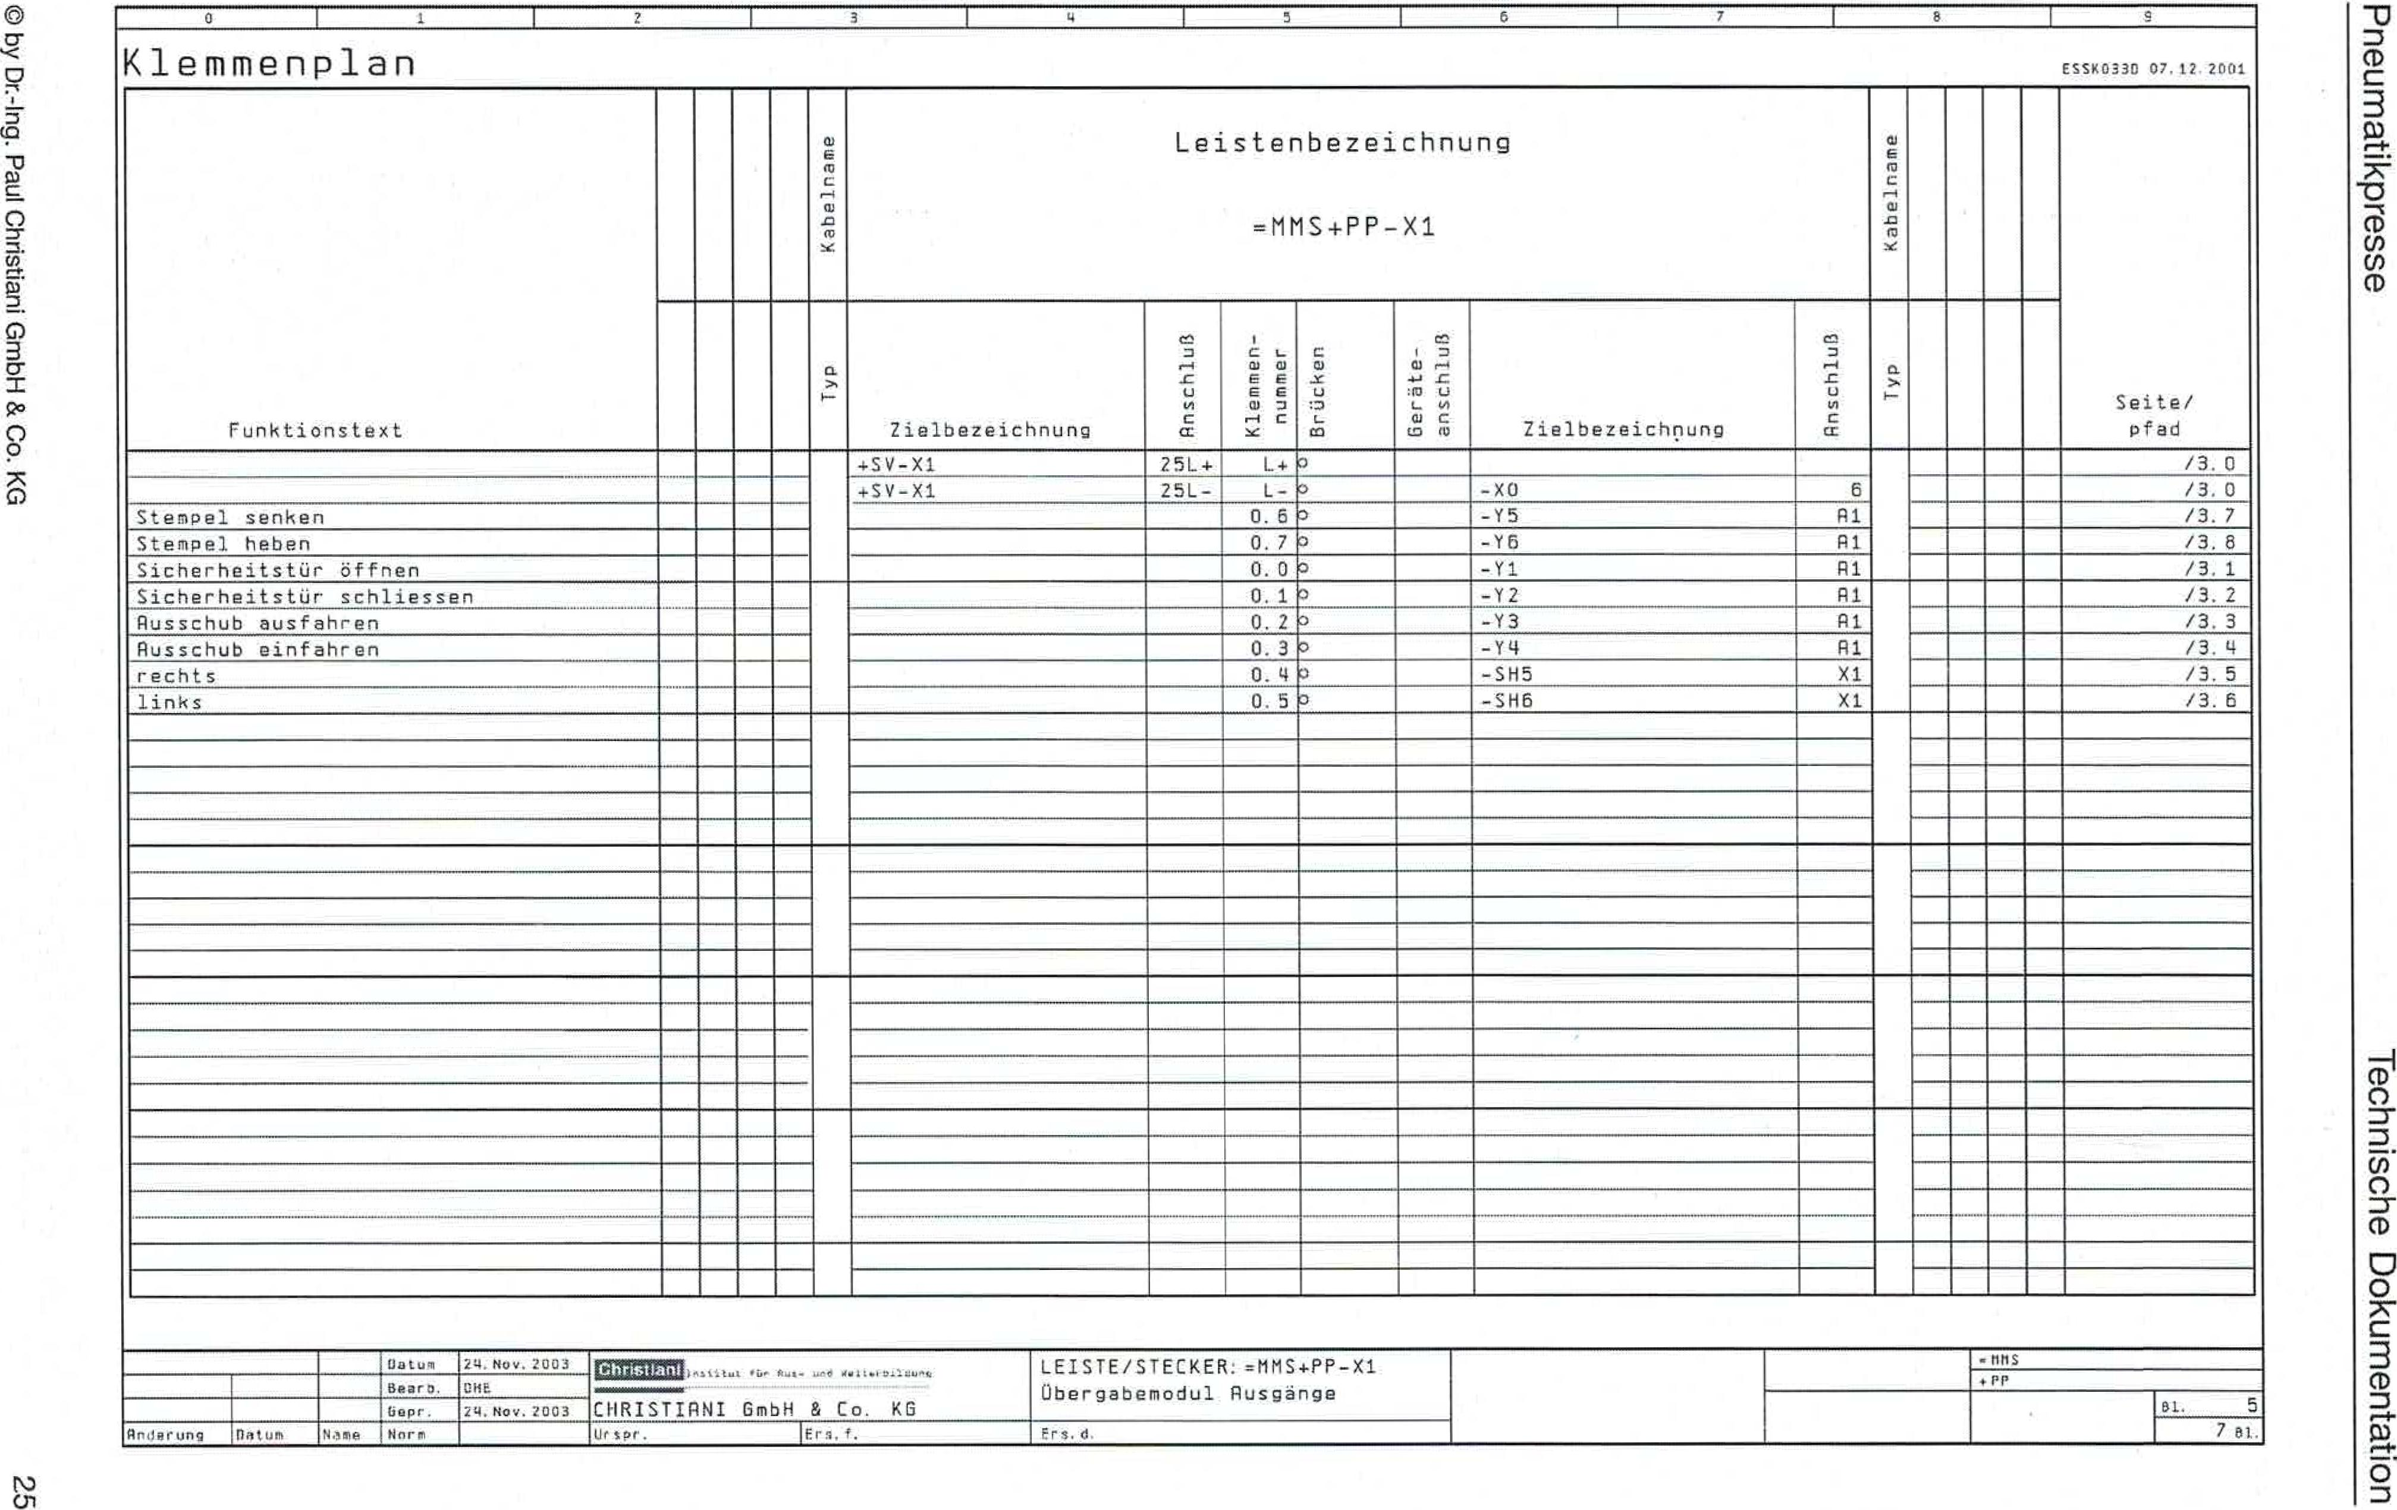

1

3

ESSK0330 07.12.2001

Terminal diagram

© by Dr. ng. Paul Christiani GmbH & Co. KG

cn

Assaithigewneud

uopluawmioa agospqoai

|  |  |  |  |  |  |  |  |  |  |  |  |  |  |  |  |  |  |  |
| --- | --- | --- | --- | --- | --- | --- | --- | --- | --- | --- | --- | --- | --- | --- | --- | --- | --- | --- |
| Function text |  |  |  |  | Iaweuteqem | Bar designation =MMS+PP-X1 | | | | | | | **IBWeiliaCie)!** |  |  |  |  | Page/ path |
|  |  |  |  | dAl | Target name | grviLpsuu | Terminal  number | uaH3nrs | lintLpsue -alerag | Target name | Connection | dAl |  |  |  |  |
|  |  |  |  |  |  | +SV-X1 |  | |  |  | |  |  |  |  |  |  | /3.0 |
|  |  |  |  |  |  |  | |  |  | |  |  |  |  |  | /3.0 |
| Rubber stamp reduce |  |  |  |  |  |  | |  |  | |  |  |  |  |  | /3.7 |
| Raise stamp |  |  |  |  |  |  | |  |  | |  |  |  |  |  | /3.8 |
| Security door open |  |  |  |  |  |  | |  |  | |  |  |  |  |  | /3.1 |
| Safety tbr close |  |  |  |  |  |  |  | |  |  | |  |  |  |  |  |  | /3.2 |
| Extend the thrust |  |  |  |  |  |  | |  |  | |  |  |  |  |  | /3.3 |
| Retract the soot thrust |  |  |  |  |  |  | |  |  | |  |  |  |  |  | /3.4 |
| right |  |  |  |  |  |  | |  |  | |  |  |  |  |  | /3.5 |
| left |  |  |  |  |  |  | |  |  | |  |  |  |  |  | /3.6 |
|  |  |  |  |  |  |  |  | |  |  | |  |  |  |  |  |  |  |
|  |  |  |  |  |  |  | |  |  | |  |  |  |  |  |  |
|  |  |  |  |  |  |  | |  |  | |  |  |  |  |  |  |
|  |  |  |  |  |  |  | |  |  | |  |  |  |  |  |  |
|  |  |  |  |  |  |  | |  |  | |  |  |  |  |  |  |
|  |  |  |  |  |  |  |  | |  |  | |  |  |  |  |  |  |  |
|  |  |  |  |  |  |  | |  |  | |  |  |  |  |  |  |
|  |  |  |  |  |  |  | |  |  | |  |  |  |  |  |  |
|  |  |  |  |  |  |  | |  |  | |  |  |  |  |  |  |
|  |  |  |  |  |  |  | |  |  | | a |  |  |  |  |  |
|  |  |  |  |  |  |  |  | | Nom_ |  | |  |  |  |  |  |  |  |
|  |  |  |  |  |  |  | |  |  | |  |  |  |  |  |
|  |  |  |  |  |  |  | |  |  | |  |  |  |  |  |  |
|  |  |  |  |  |  |  | |  |  | |  |  |  |  |  |  |
|  |  |  |  |  |  |  | |  |  | |  |  |  |  |  |  |
|  |  |  |  |  |  |  |  | |  |  | |  |  |  |  |  |  |  |
|  |  |  |  |  |  |  | |  |  | |  |  |  |  |  |  |
|  |  |  |  |  |  |  | |  |  | |  |  |  |  |  |  |
|  |  |  |  |  |  |  | |  |  | |  |  |  |  |  |  |
|  |  |  | |  |  | |  |  |
|  |  |  |  |  |  |  |  | |  |  | |  |  |  |  |  |  |  |
|  |  |  |  |  |  |  | |  |  | |  |  |  |  |  |  |

November 21, 2503

0116

24, Nay. 2003

CHRISTIANS GmbH & Co. KG

Ursor.

STRIP/PLUG:=MMS+PP-X1 transfer moduleExits

Fri s.

B1. 5

7 as.

Date

Ardpirung

Date

toma

Beam

bap, Harm

+PP

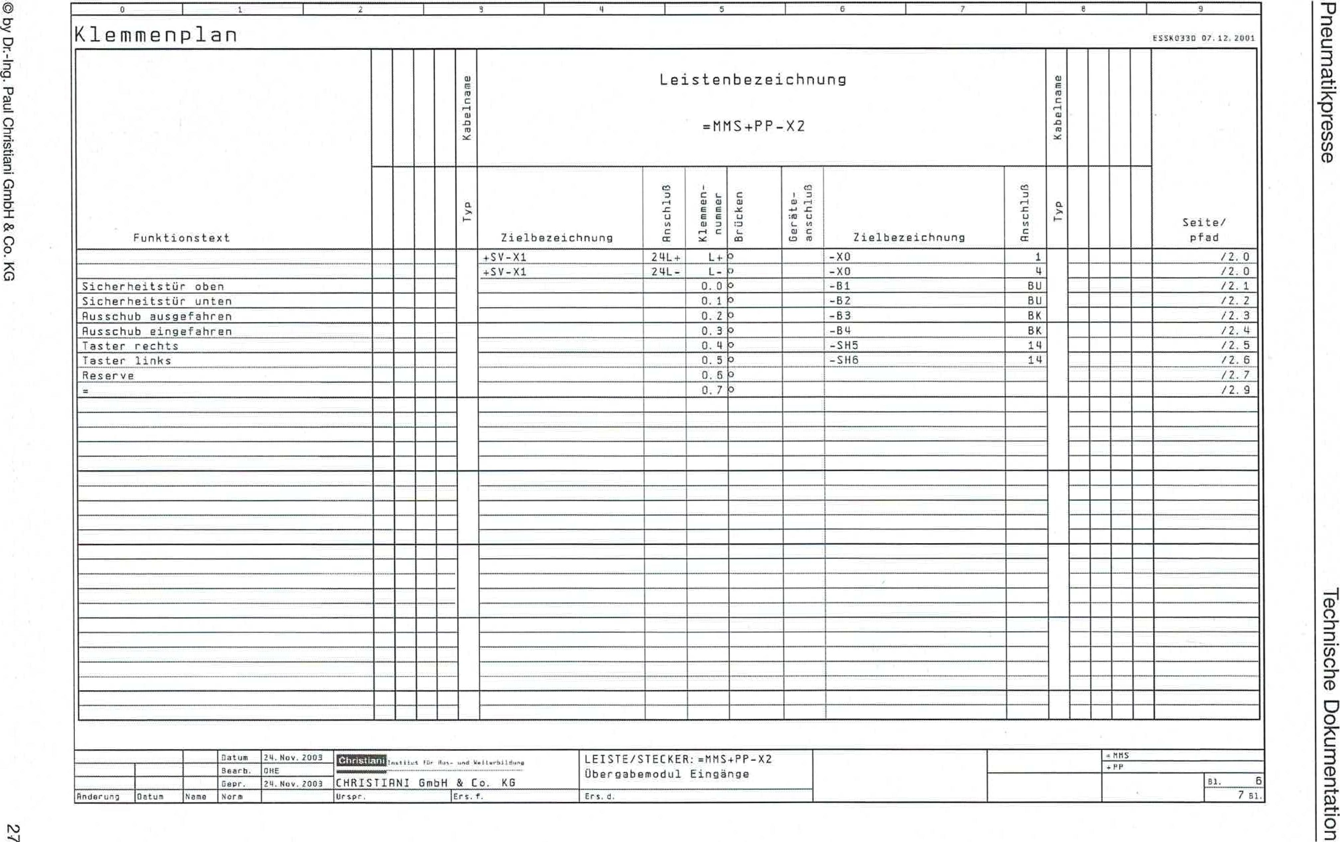

3

2

535k0330 07, 12. 2001

Terminal diagram

© by Dr.-Ing. Paul Christian' GmbH & Co. KG

assalcbmewneud

uopluawmioci agospqoal

|  |  |  |  |  |  |  |  |  |  |  |  |  |  |  |  |  |  |  |
| --- | --- | --- | --- | --- | --- | --- | --- | --- | --- | --- | --- | --- | --- | --- | --- | --- | --- | --- |
| Function text |  |  |  |  | Cable nameI | Bar designation =MMS+PP-X2 | | | | | | | IatueutacieN |  |  |  |  | Page/ path |
|  |  |  |  | dAl | Target name | enttpsuu | Terminal  number | ua)pri_ng | uniyasue -alsmJag | Target name | unitosub | dA j |  |  |  |  |
|  |  |  |  |  |  | +SV-X1 | 24L+ | L*3 | |  | -X0 | 1 |  |  |  |  |  | /2.0 |
|  |  |  |  |  | +SV-X1 | 24L- | L- | |  | -X0 | 4 |  |  |  |  | /2.0 |
| Security door above |  |  |  |  |  |  | 0.03 | |  | -131 | BU |  |  |  |  | /2.1 |
| Security gate below |  |  |  |  |  |  | 0.13 | |  | -B2 | BU |  |  |  |  | /2.2 |
| Rushub extended |  |  |  |  |  |  | 0.20 | |  | -83 | BK |  |  |  |  | /2.3 |
| Rushub retracted |  |  |  |  |  |  |  | 0.33 | |  | -B4 | BK |  |  |  |  |  | /2.4 |
| button right |  |  |  |  |  |  | 0.40 | |  | -SH5 | 14 |  |  |  |  | /2.5 |
| button left |  |  |  |  |  |  | 0.50 | |  | -SH6 | 14 |  |  |  |  | /2.6 /2.7 |
| reserve |  | 0.63 | |  |  |  |
| . |  |  |  |  |  |  | 0.7 | |  |  |  |  |  |  |  | /2.9 |
|  |  |  |  |  |  |  |  |  | |  |  |  |  |  |  |  |  |  |
|  |  |  |  |  |  |  |  | |  |  |  |  |  |  |  |  |
|  |  |  |  |  |  |  |  | |  |  |  |  |  |  |  |  |
|  |  |  |  |  |  |  |  | |  |  |  |  |  |  |  |  |
|  |  |  |  |  |  |  |  | |  |  |  |  |  |  |  |  |
|  |  |  |  |  |  |  |  |  | |  |  |  |  |  |  |  |  |  |
|  |  |  |  |  |  |  |  | |  |  |  |  |  |  |  |  |
|  |  |  |  |  |  |  |  | |  |  |  |  |  |  |  |  |
|  |  |  |  |  |  |  |  | |  |  |  |  |  |  |  |  |
|  |  |  |  |  |  |  |  | |  |  |  |  |  |  |  |  |
|  |  |  |  |  |  |  |  |  | |  |  |  |  |  |  |  |  |  |
|  |  |  |  |  |  |  |  | |  |  |  |  |  |  |  |  |
|  |  |  |  |  |  |  |  | |  |  |  |  |  |  |  |  |
|  |  |  |  |  |  |  |  | |  |  |  |  |  |  |  |  |
|  |  |  |  |  |  |  |  | |  |  |  |  |  |  |  |  |
|  |  |  |  |  |  |  |  |  | |  |  |  |  |  |  |  |  |  |
|  |  |  |  |  |  |  |  | |  |  |  |  |  |  |  |  |
|  |  |  |  |  |  |  |  | |  |  |  |  |  |  |  |  |
|  |  |  |  |  |  |  |  | |  |  |  |  |  |  |  |  |
|  |  |  |  | |  |  |  |  |  |
|  |  |  |  |  |  |  |  |  | |  |  |  |  |  |  |  |  |  |
|  |  |  |  |  |  |  |  | |  |  |  |  |  |  |  |  |

Oatom 24.November 20031=121

**tamiaut 1[1. Weilurb41.0,**

Bearh.Geo,

Naito **NW,.**

STRIP/PLUG:=MNS+PP-X2Transfer module entrances

Ers. d.

MMS

Anderuno Date

ORE

24.**NOV.**Z003

Ur sc.'. lent. T.

51.6

7 years old

ININNEMMIIIIMWMASY

CHRISTIRNI GmbH & Co. KG

**4 PLC programming**

Pneumatic press Technical documentation

0 by Dr.-Ing. Paul Christian' GmbH & Co. KG

29

**4.1 Program description**

The pneumatic press is designed for two operating modes.

Firstly, for automatic operation with feeding by e.g. a hand­storage device and also automatic removal after pressing­occurrence.

Secondly, for manual operation with two-hand control by the­the button.

The pressing process is the same for both operating modes. Only the start of the process is controlled in one case by an interface signal (automatic mode) and in the other case by the two-hand control (manual­operation) triggered.

The two-hand control must be programmed in accordance with the relevant European Standard 574 "Two-hand control devices". A time delay of less than 0.5 seconds between the activation of the two buttons must be observed.­In addition, the pressing process must be interrupted if min­at least one of the two buttons is released.

Before starting the operation, the press must move to the home position. The home position is defined as the feed extended (B3), the top (BI), and the ram up (without monitoring). Therefore, Y1, then Y6, and then Y3 must be activated first. If operation is then started and both manual control buttons are pressed simultaneously within 0.5 seconds, the pressing process is initiated. By activating valve Y4, the feed is retracted, and then the safety valve is activated by actuating Y2.

closed. Now the stamp can be lowered and raised again­Since there is no monitoring of the position of the stamp, theThe up and down travel times can be controlled via two time periods. Time Ti corresponds to the time the punch is on its way down, including the pressing time. Time T2 corresponds to the time the punch is moving from the lower­to the upper position. Once the ram is back in the upper position, the safety door is opened. With the door open, the extension is extended again. The work cycle is thus completed.

As a guideline for the times Ti and T2, 3.0 seconds can be assumedbecome.

If the press is operated with upstream and downstream functional assembliesThe two buttons do not need to be pressed. Instead, an interface signal from the upstream functional module must be used.­to stop the pressing process. Furthermore, an interface signalfrom the pneumatic press, which informs the subsequent device when the pressing process is finished and the work stack is ready for collection.

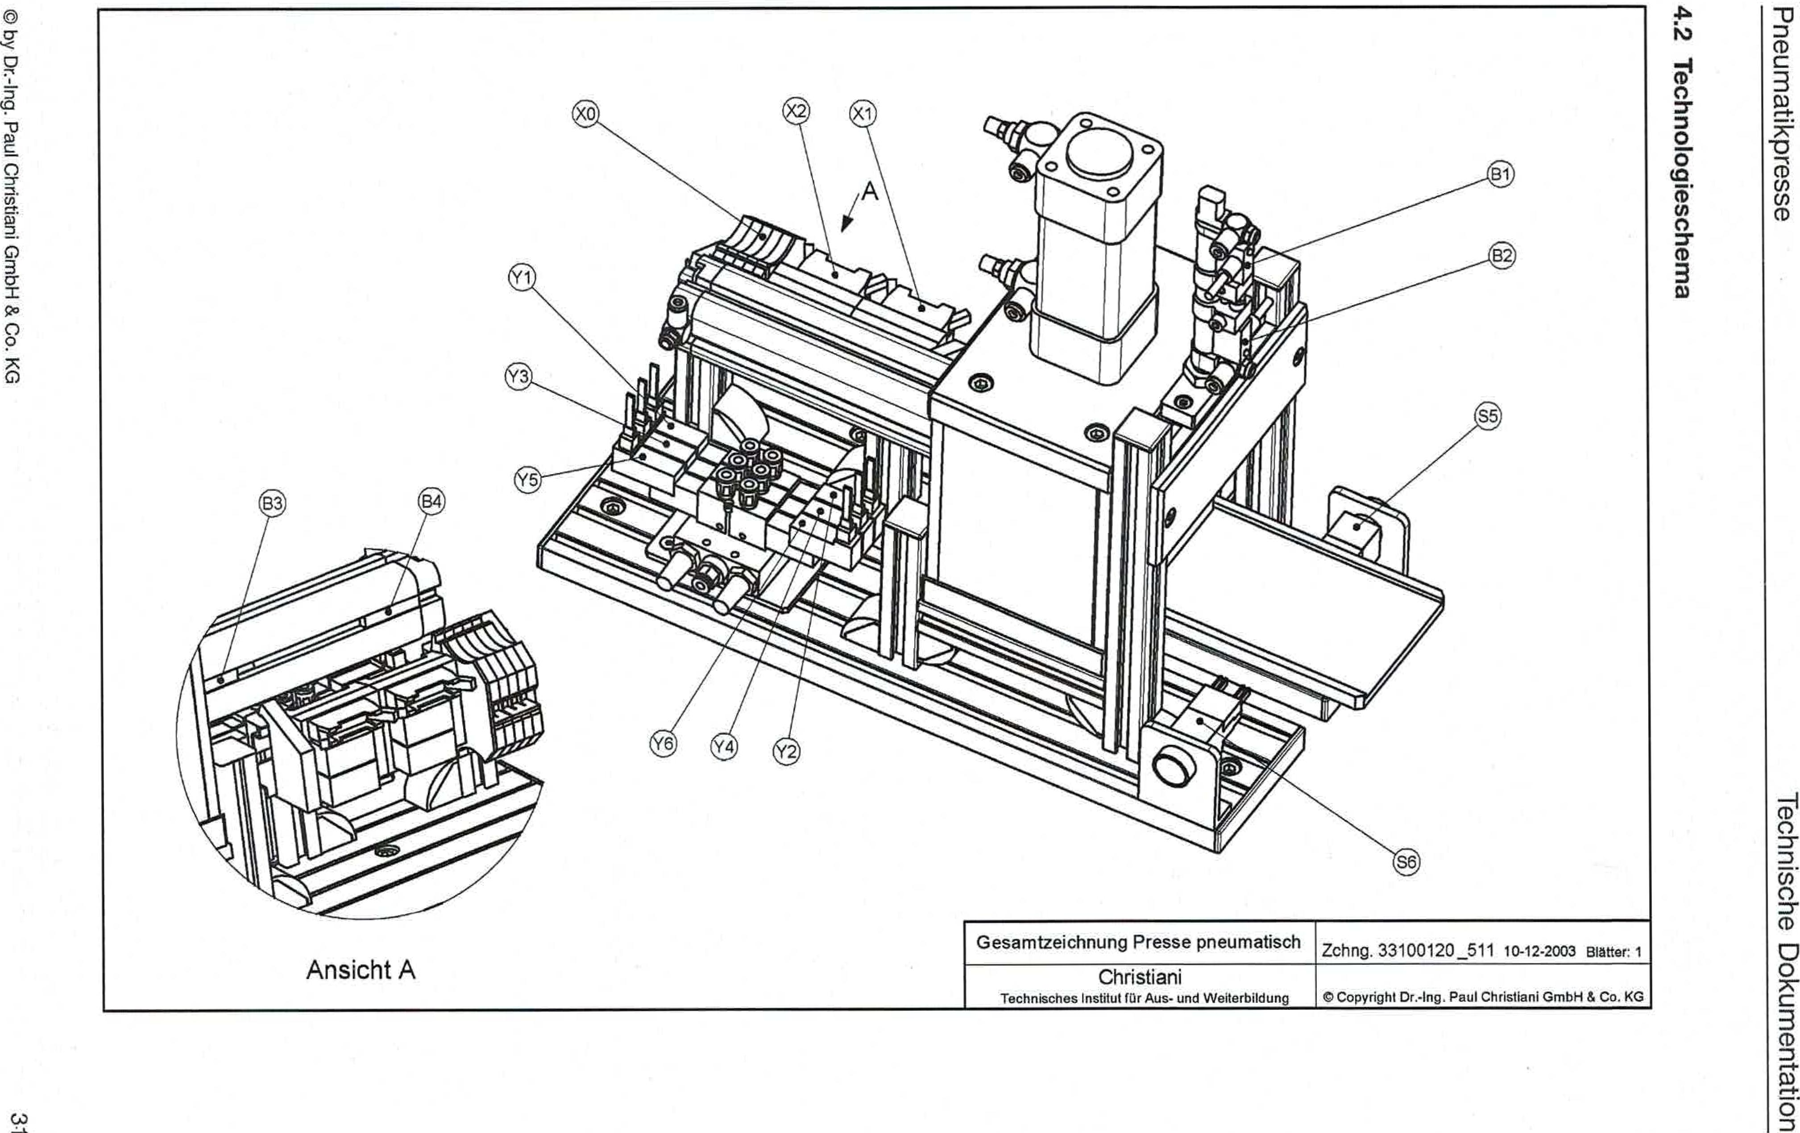

View A

© by Dr.-Ing. Paul Christiani GmbH & Co. KG

**ewatiosa!bolouqoai g•i7**

assalthmewneud

uopluownwa agospLioal

General drawing of pneumatic press drawing 33100120_51110-12-2003 Pages 1

Christiani

Technical Institute for Training and Further Education ©Copyright Dr.-lug. Paul Christiani GmbH & Co. KG

**4.3 Function plan**

Pneumatic press

Technical documentation

**(Transitions) Steps**

Car - Impulse

**Forwarding conditions**

**Actions**

Font 1

Start signal OR 2-hand operation)

HP in basic position

Step 8

|  |  |
| --- | --- |
| S | Stamp hach |
| S | Tar on |
| S | Extend extension |

Step 2

S Retract feed

S Tar to

Feed is retracted

Step 3

Tar is too

Waiting times expired Ti

Step 4

Step 6

Step 5

Waiting times expired T2

|  |  |
| --- | --- |
| S | Press off |
| S | Start waiting time T1 |

|  |  |
| --- | --- |
| S | Press on |
| S | Start waiting time T2 |

S Tar on

vStep 7

© by Dr.-Ing. Paul Christiani GmbH & Co. KG

33

'Mr 1st °ben

Pneumatic press Technical documentation

© by Dr.-Ing. Paul Christiani GmbH & Co. KG

**35**

Step 7 Extend extension

Extension extended

Step 8

**V**

Step 2

**4.4 Program steps**

Pneumatic press Technical documentation

© by Dr.-Ing. Paul Christiani GmbH & Co. KG **37**

|  |
| --- |
| **Step: 1 1Function: Basic position** |
| **Comment:**  In this step, the PP is moved to the home position by an initialization signal. (Home position: feed extended, punch up, till-above)  Attention: For safety reasons, the press is always operated in 2-hand­Operation operated: ie, both hands operate the right and left buttons located on the press. The time delay between pressing both buttons should be a maximum of 0.5 seconds! |
| **Betting conditions:**  Signal operating mode automatic (Impels) |
| **Reset conditions: •**  Step 2  or  Error collector |
| **Actions: Mr**lift AND extend extension AND lift ram |

|  |
| --- |
| **Step: 2 Function: Retract extension** |
| **Comment:**Retract feed |
| **Betting conditions:**  (Step 1 or 6) AND Automatic started AND Start pulse AND Home position |
| **Reset conditions:**Step 3  or  Error collector |
| **Actions: Retract extension** |

|  |
| --- |
| **Step: 3 Function: Close door** |
| **Comment:** TO-close |
| **Betting conditions:**Font 2  AND  84 |
| **Reset conditions:**Step 4  or  Error collector |
| **Actions: Close door** |

Pneumatic press Technical documentation

© by Dr-Ing. Paul Christiani GmbH & Co_ KG 39

|  |
| --- |
| **Step 4 Function: Stamp off** |
| **Comment: Press off** |
| **Betting conditions:**Step 3  AND  B2 |
| **Reset conditions: Step**5  or  Error collector |
| **Promotions: Stamp off*AND*Start waiting time Ti** |

|  |
| --- |
| **Step 5 1 Function: Stamp on** |
| **Comment:**Press on |
| **Betting conditions:**Step 4  AND  **Ti** |
| **Reset conditions:**Step 6  or  Error collector |
| **Actions: Stamp up AND start waiting time T2** |

|  |
| --- |
| **Step: 6 Function: Door open** |
| **Comment: Tiir on** |
| **Betting conditions:**Step 5  AND  T2 |
| **Reset conditions:**Step 7  or  Error collector |
| **Actions: Gate open** |

Pneumatic press Technical documentation

© by Dr.-Ing. Paul Christiani GmbH & Co. KG 41

|  |
| --- |
| **Step: 7 Function: Extend extension** |
| **Comment:**Ejectionextend |
| **Selz conditions:**Step 6  AND  B1 |
| **Betting conditions:**Step 8  or  Error collector |
| **Actions: Extend extension** |

|  |
| --- |
| **Step: 8 Function: Chain end** |
| **Comment:**  This step is active when the extension is extended. No action is taken.­leads. |
| **Setting conditions:**Step 7  AND  B3 |
| **Fluck setting conditions:**Step 2  or  Error collector |
| **Actions: None** |

**5 Commissioning instructions**

Pneumatic press Technical documentation

0 by Dr.-Ing. Paul Christiani GmbH & Co. KG

43

***Condition***

***Visual inspection***

|  |  |
| --- | --- |
| Arrangement of components according to plan |  |
| Arrangement of wiring and piping |  |
| Alignment of the components to each other |  |
| Labeling of components (readable from the front or from the right) |  |
| Cleanliness (no stripping residue in the grooves, etc.) |  |
| Scratch-free eyelashes |  |

***Checking mechanical connections***

|  |
| --- |
| Strength of the assembled parts  Ease of movement of the extension over the full travel range. Firm fit of the solenoid valve on the mounting bracket.  Correct size of the extension level above the table  Firm fit of the solenoid valve on the mounting bracket |

***Cyber ​​testing of pneumatic connections***

|  |
| --- |
| Compressed air hoses firmly connected  Compressed air hoses laid with sufficient bending radiusCompressed air connectors have sufficient hold |

***Checking electrical connections***

|  |
| --- |
| Wire end sleeves pressed correctly  Wires correctly inserted into terminals and firmly screwed or clamped. Clamping bridges firmly screwed, no protruding cutting residues |

***Function jump mechanical***

|  |
| --- |
| Mobility of mechanical components, especially extension  All movements can be carried out within the intended area The workpiece fits into the ejection opening as intended |

***Pneumatic functional test***

|  |  |
| --- | --- |
| Steffen Make sure the pneumatic system is closed. Set the supply air pressure to 4 bar eh  Establish the compressed air connection.  Check for leaking stems. | |
| Check that the solenoid valves function according to the circuit diagram:  To do this, operate the manual triggers on solenoid valves Y1 and Y2. Operating Y1 opens the safety door, while Y2 closes the safety door. |

Activate the manual triggers on solenoid valves Y3 and Y4. Actuating Y3 retracts the extension, while Y4 extends the extension.

|  |
| --- |
| Activate the manual triggers on solenoid valves Y5 and Y6. Actuating Y5 retracts the ram, while Y6 extends the ram. |

***Condition***

Technical documentation Pneumatic press

***Electrical functional test***

|  |
| --- |
| Without connecting the power supply:  Check for continuity between the "+" and "-" terminals on the terminal blocks. If continuity is present, eliminate the short circuit! |

Checking the correct polarity of non-short-circuit-proof components:

Are all reed switches correctly connected to the power supply?

Steffen you establish the 24 V DC power supply and the ground connection.

Check the function of sensor 51.

Measuring 24V at terminal X2 0.0 means safety door up.

Check the function of sensor B2.

Measuring 24V at terminal X2 0.1 means: safety door down.

Check the function of sensor B3.

Measuring 24V at terminal X2 0.2 means: extension extended.

Check the function of sensor B4.

Measuring 24V at terminal X2 0.3 means: extension retracted.

Check the function of the SH5 button.

Measuring 24V at terminal X2 0.4 means: right button pressed.

Check the function of the SH6 sensor.

Measuring 24V at terminal X2 0.5 means: left button activated.

|  |
| --- |
| Check the function of the solenoid valves.  Controlling 24V at terminal X1 0.0 must open the safety door. Controlling 24V at terminal X1 0.1 must close the safety door. Controlling 24V at terminal X1 0.2 must extend the extension. Controlling 24V at terminal X1 0.3 must retract the extension. Controlling 24V at terminal X1 0.6 must lower the piston.Controlling 24V at terminal X1 0.7 must raise the stamp. |

The following applies to all terminals:

If no voltage is applied, the cylinder remains in its current position.

|  |
| --- |
| Check the function of the button illumination:  Controlling 24V at terminal X1 0.5 should illuminate the right button. Controlling 24V at terminal X1 0.6 should illuminate the left button. |

Place, date, signature

Carried out

44

0 by Dr.-Ing. Paul Christiani GmbH & Co. KG